#include <stdio.h>

#include <stdlib.h>

#include <string.h>

#define CLS system("cls")

// Franklyn Gonzalez, last edited 03/07/2019

void roman(); // Calls Roman Numerals

main() {

int input = 0;

printf("Enter a Roman Numeral Value from 1-1000.\n Non-Roman Numeral numbers will return empty.\n\n Enter '-1' to exit.\n"); // prints menu

while (input != -1)

{

scanf("%i", &input);

CLS; // clears input

roman(input); // calls function

}

}

void roman(input)

{

switch (input)

{

case 1:

input = 73;

input = (char)input;

printf("%c \n", input);

input = 0;

break;

// I

case 5:

input = 86; // ASCII Number of Character

input = (char)input;

printf("%c \n", input);

input = 0;

break;

// V

case 10:

input = 88; // ASCII Number of Character

input = (char)input;

printf("%c \n", input);

input = 0;

break;

// X

case 50:

input = 76; // ASCII Number of Character

input = (char)input;

printf("%c \n", input);

input = 0;

break;

// L

case 100:

input = 67; // ASCII Number of Character

input = (char)input;

printf("%c \n", input);

input = 0;

// C

break;

case 500:

input = 68; // ASCII Number of Character

input = (char)input;

printf("%c \n", input);

input = 0;

break;

// D

case 1000:

input = 77; // ASCII Number of Character

input = (char)input;

printf("%c \n", input);

input = 0;

break;

// M

default:

break;

}

}

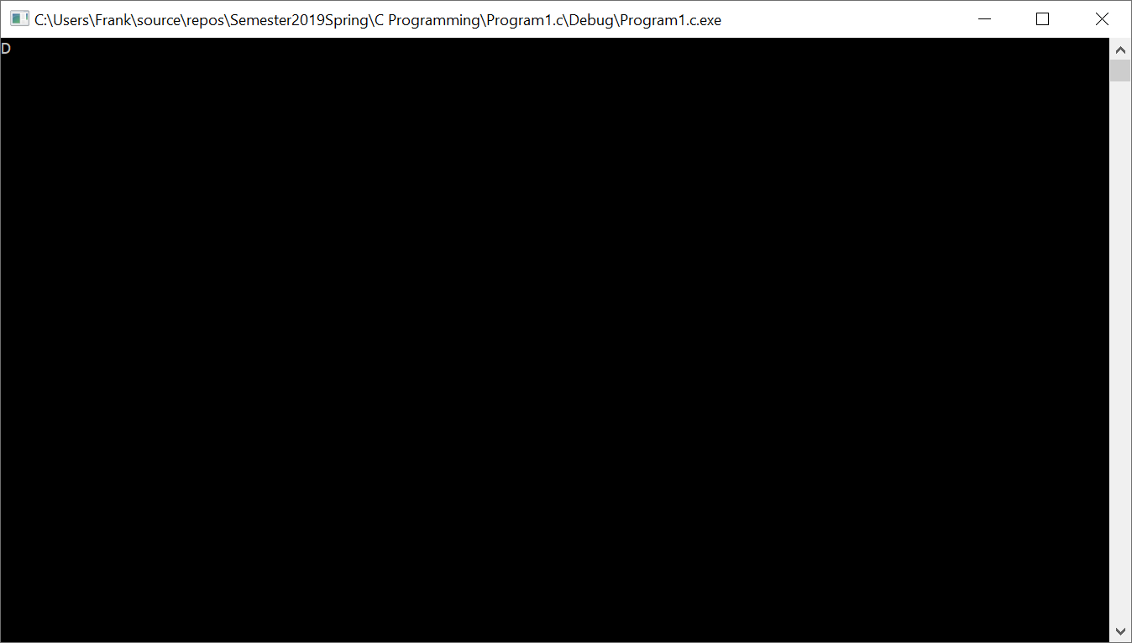

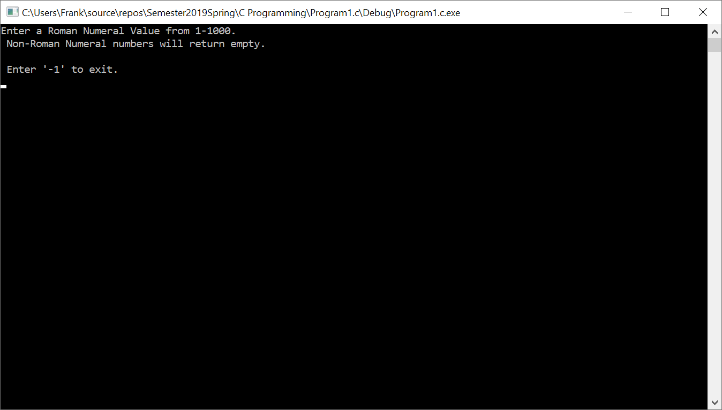

|  |  |  |
| --- | --- | --- |
| **Input**  input  roman | **Processing**  🡪 takes user roman numeral value🡪  🡪sends user input to one of the roman numerals🡪 | **Output**  Displays ASCII char  Gets ASCII number and input becomes a char |